 



CSE299: Junior Design

**Week: 03 Progress Report**

**Submitted to:** Tanzilah Noor Shabnam

**Submitted on:** 22/10/2024 **Team Name:** Machine Minds **Project Title:** Flood Guard



**Task completed:** Victim Portal [UI, Backend and Database]

**Team members**

|  |  |
| --- | --- |
| Name | ID |
| Sabbir Hossain | 2131272042 |
| Md. Misbah Khan | 2132086642 |
| Aritra Islam Saswato | 2132629642 |

# Languages and Tools

**Programming language:** JavaScript, SQL

**Framework:**

|  |  |
| --- | --- |
| **Name** | Language |
| React | JavaScript and typescript |
| MySQL | SQL |

**Middleware:**

|  |  |  |
| --- | --- | --- |
| **Name** | **Use** | **Links** |
| Leaflet | for map location and direction | https://leafletjs.com/ |

**Collaboration and storing code:** GitHub

**Contribution:**

|  |  |
| --- | --- |
| **Name** | **Contribution** |
| Md. Misbah Khan | Login & Signup[UI & firebase], map component for exact location and direction. |
| Sabbir Hossain | Victim table, Shelter Table, Modal, Badge, Table, Tab reusable component. |
| Aritra Islam Saswato | Donations Table, Backend code for get Donation, Victim and Shelter table and Database Bug fix. |

**External API:**

|  |  |  |  |
| --- | --- | --- | --- |
| **Name** | **Use** | **Links** | |
| Open Cage | converting latitude and  longitude to location name | https://opencagedata.com/api | |
| Open Street Map API v0.6 | Accessing and editing map data | | https://wiki.openstreetmap.org/wiki/API_v0.6 |

**Snippets of the Code:**

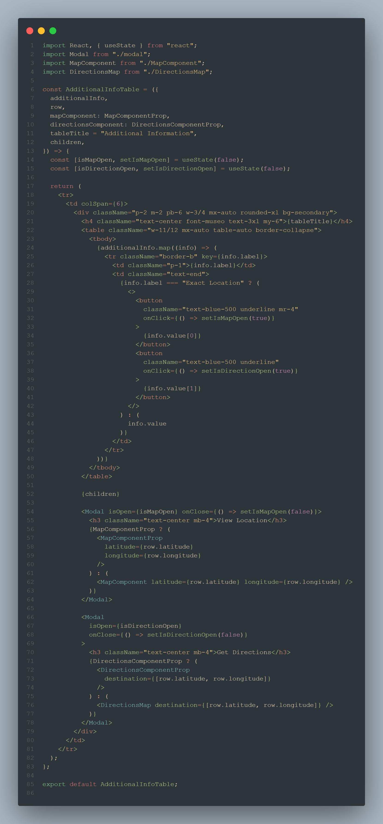

Additional Info Table

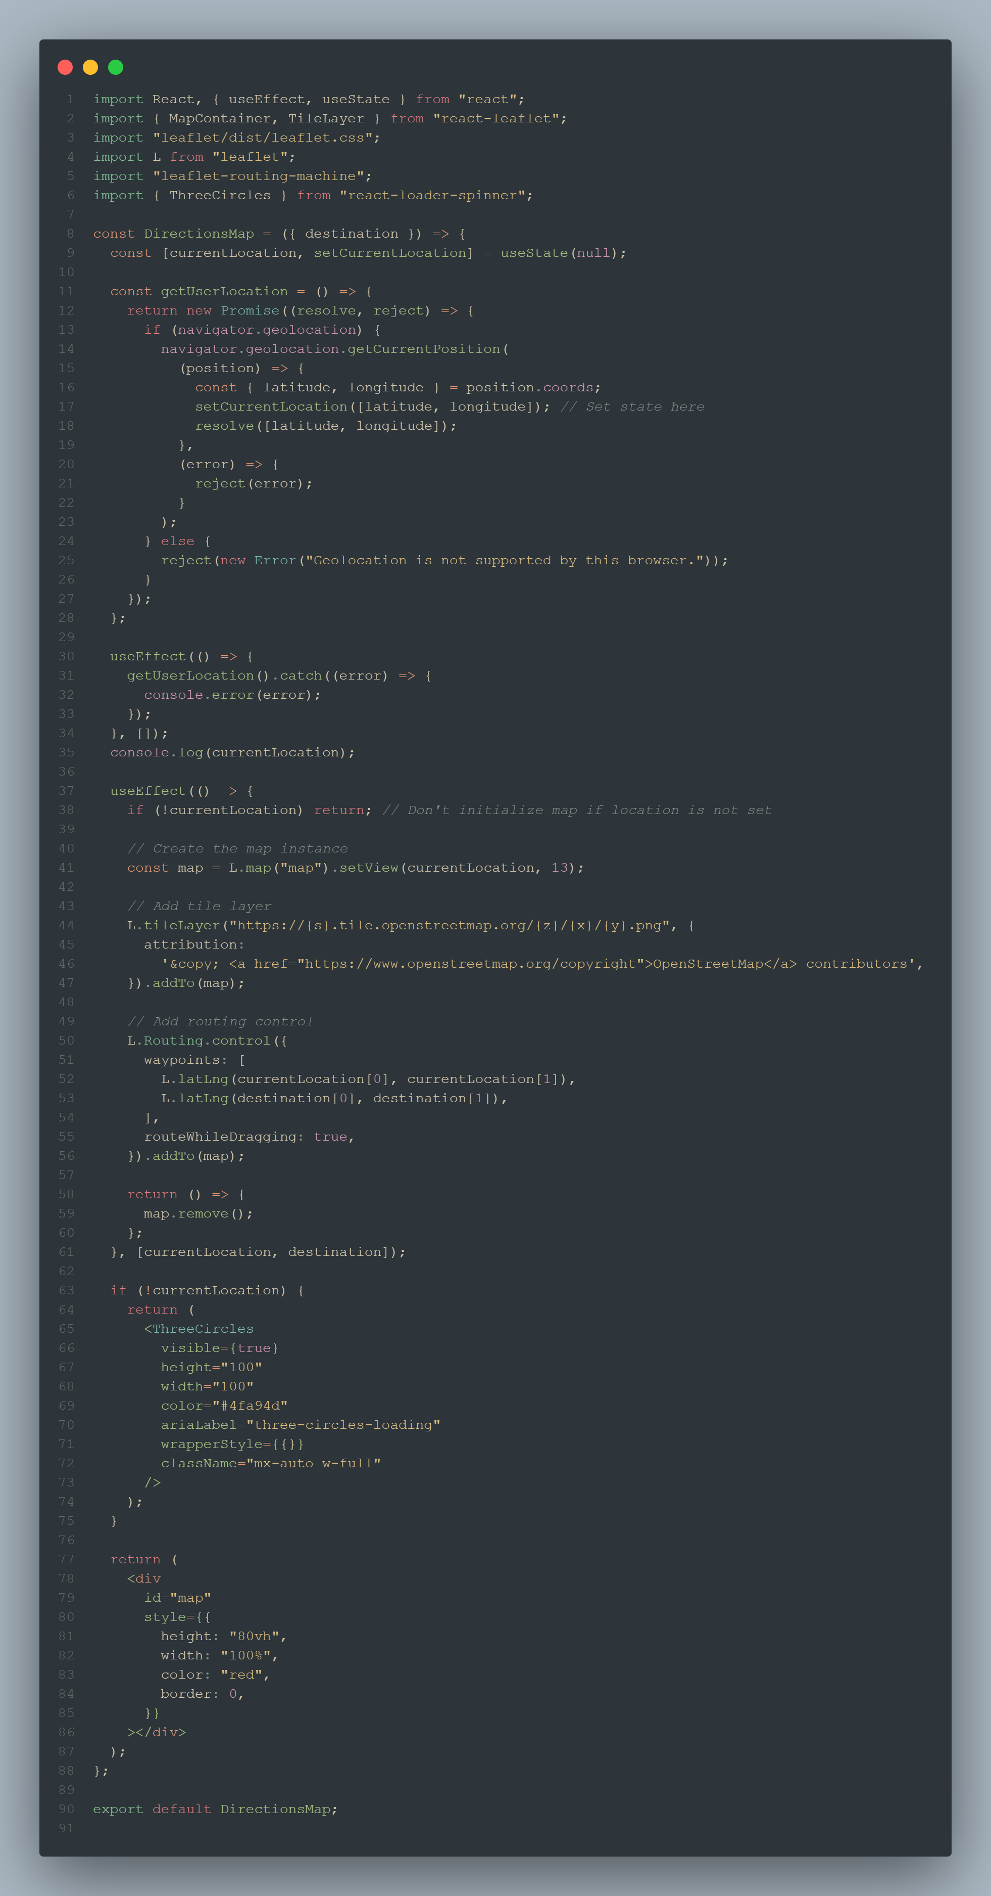

DirectionMap

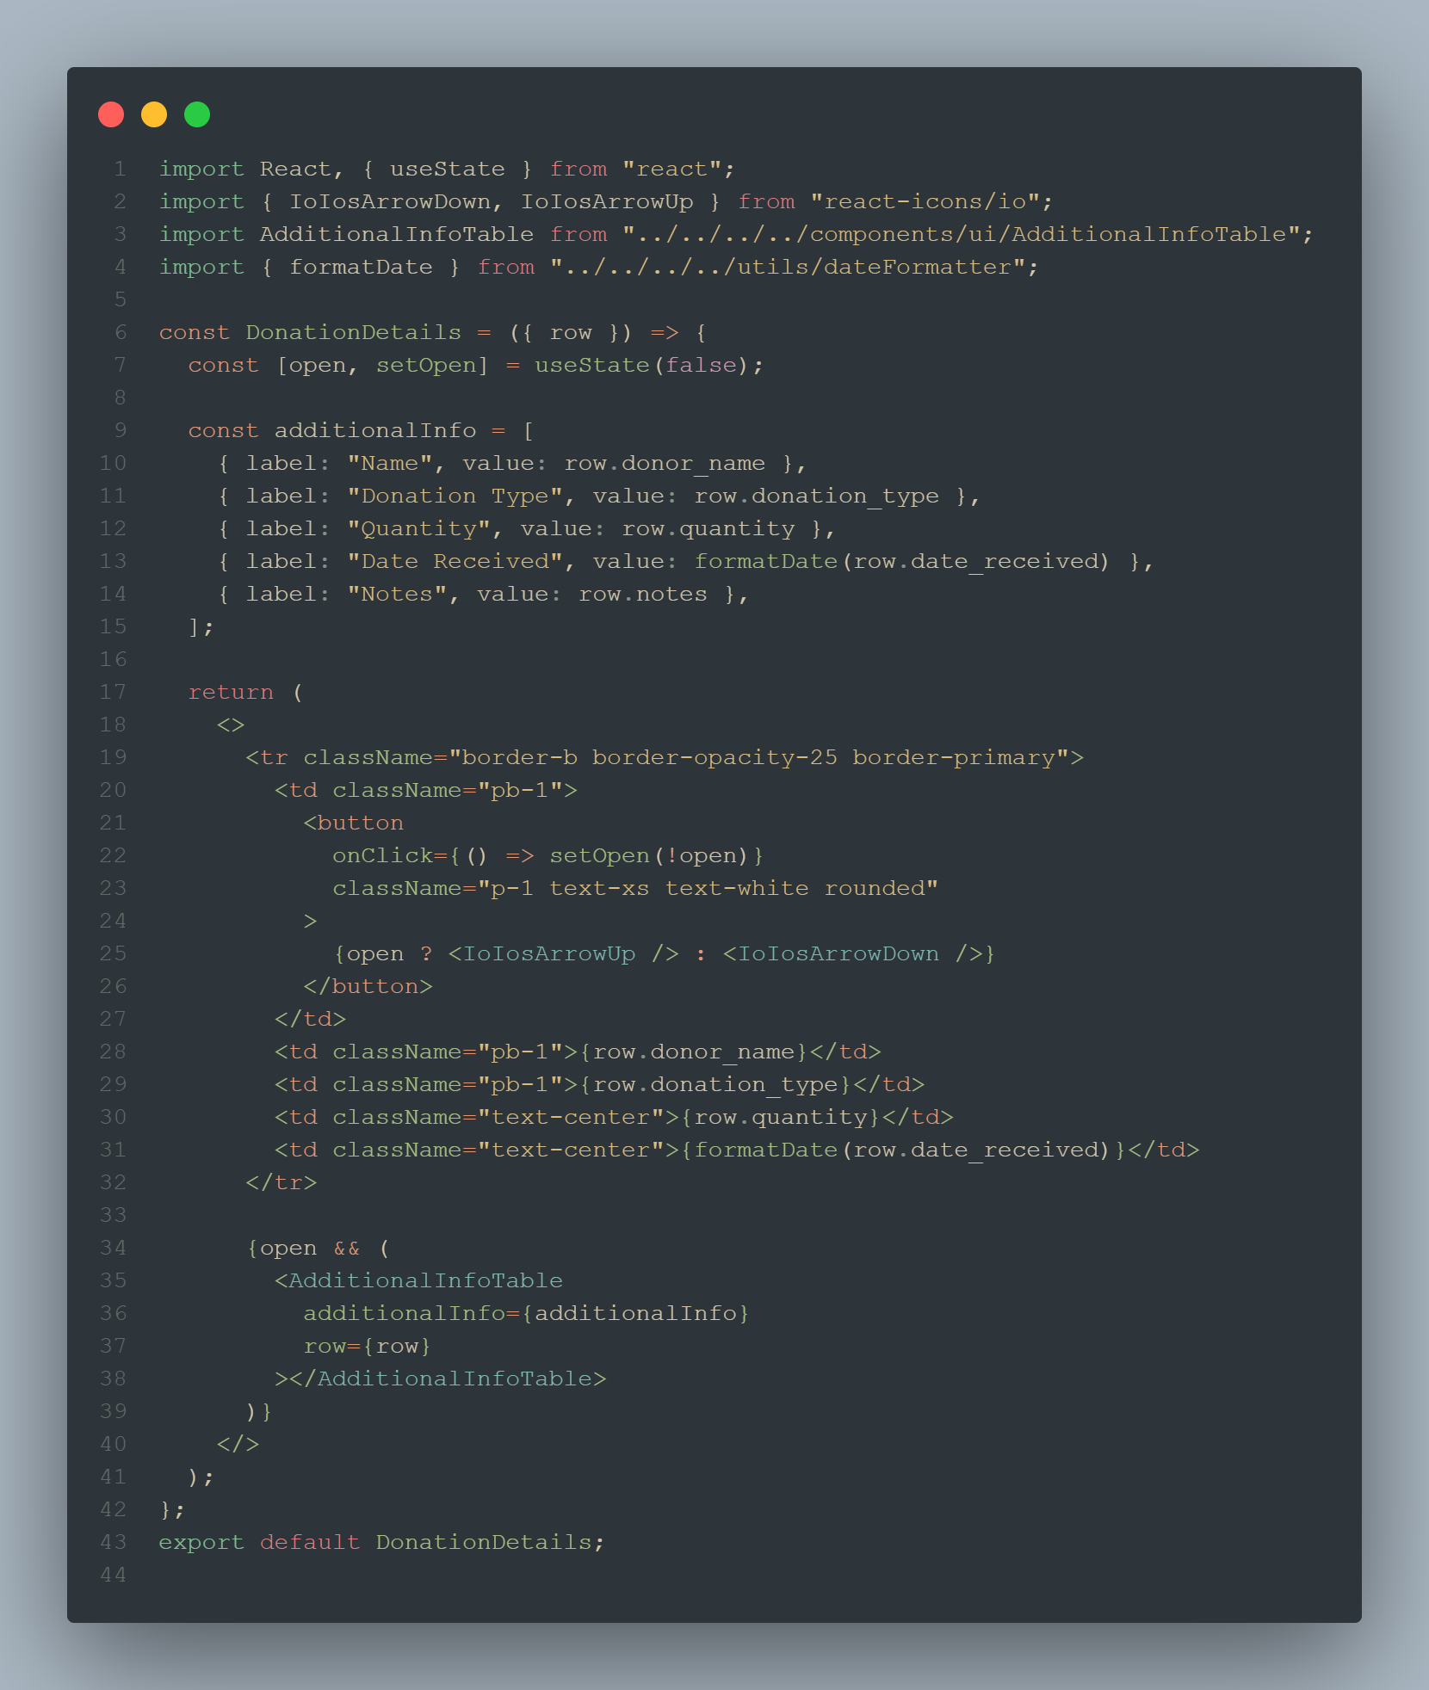

DonationDetails

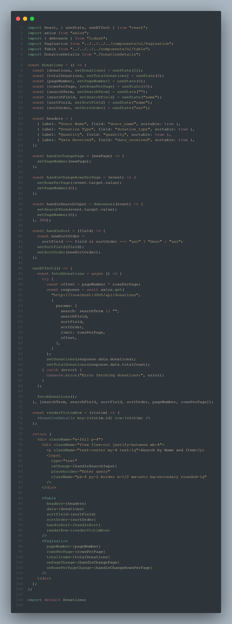

Donors

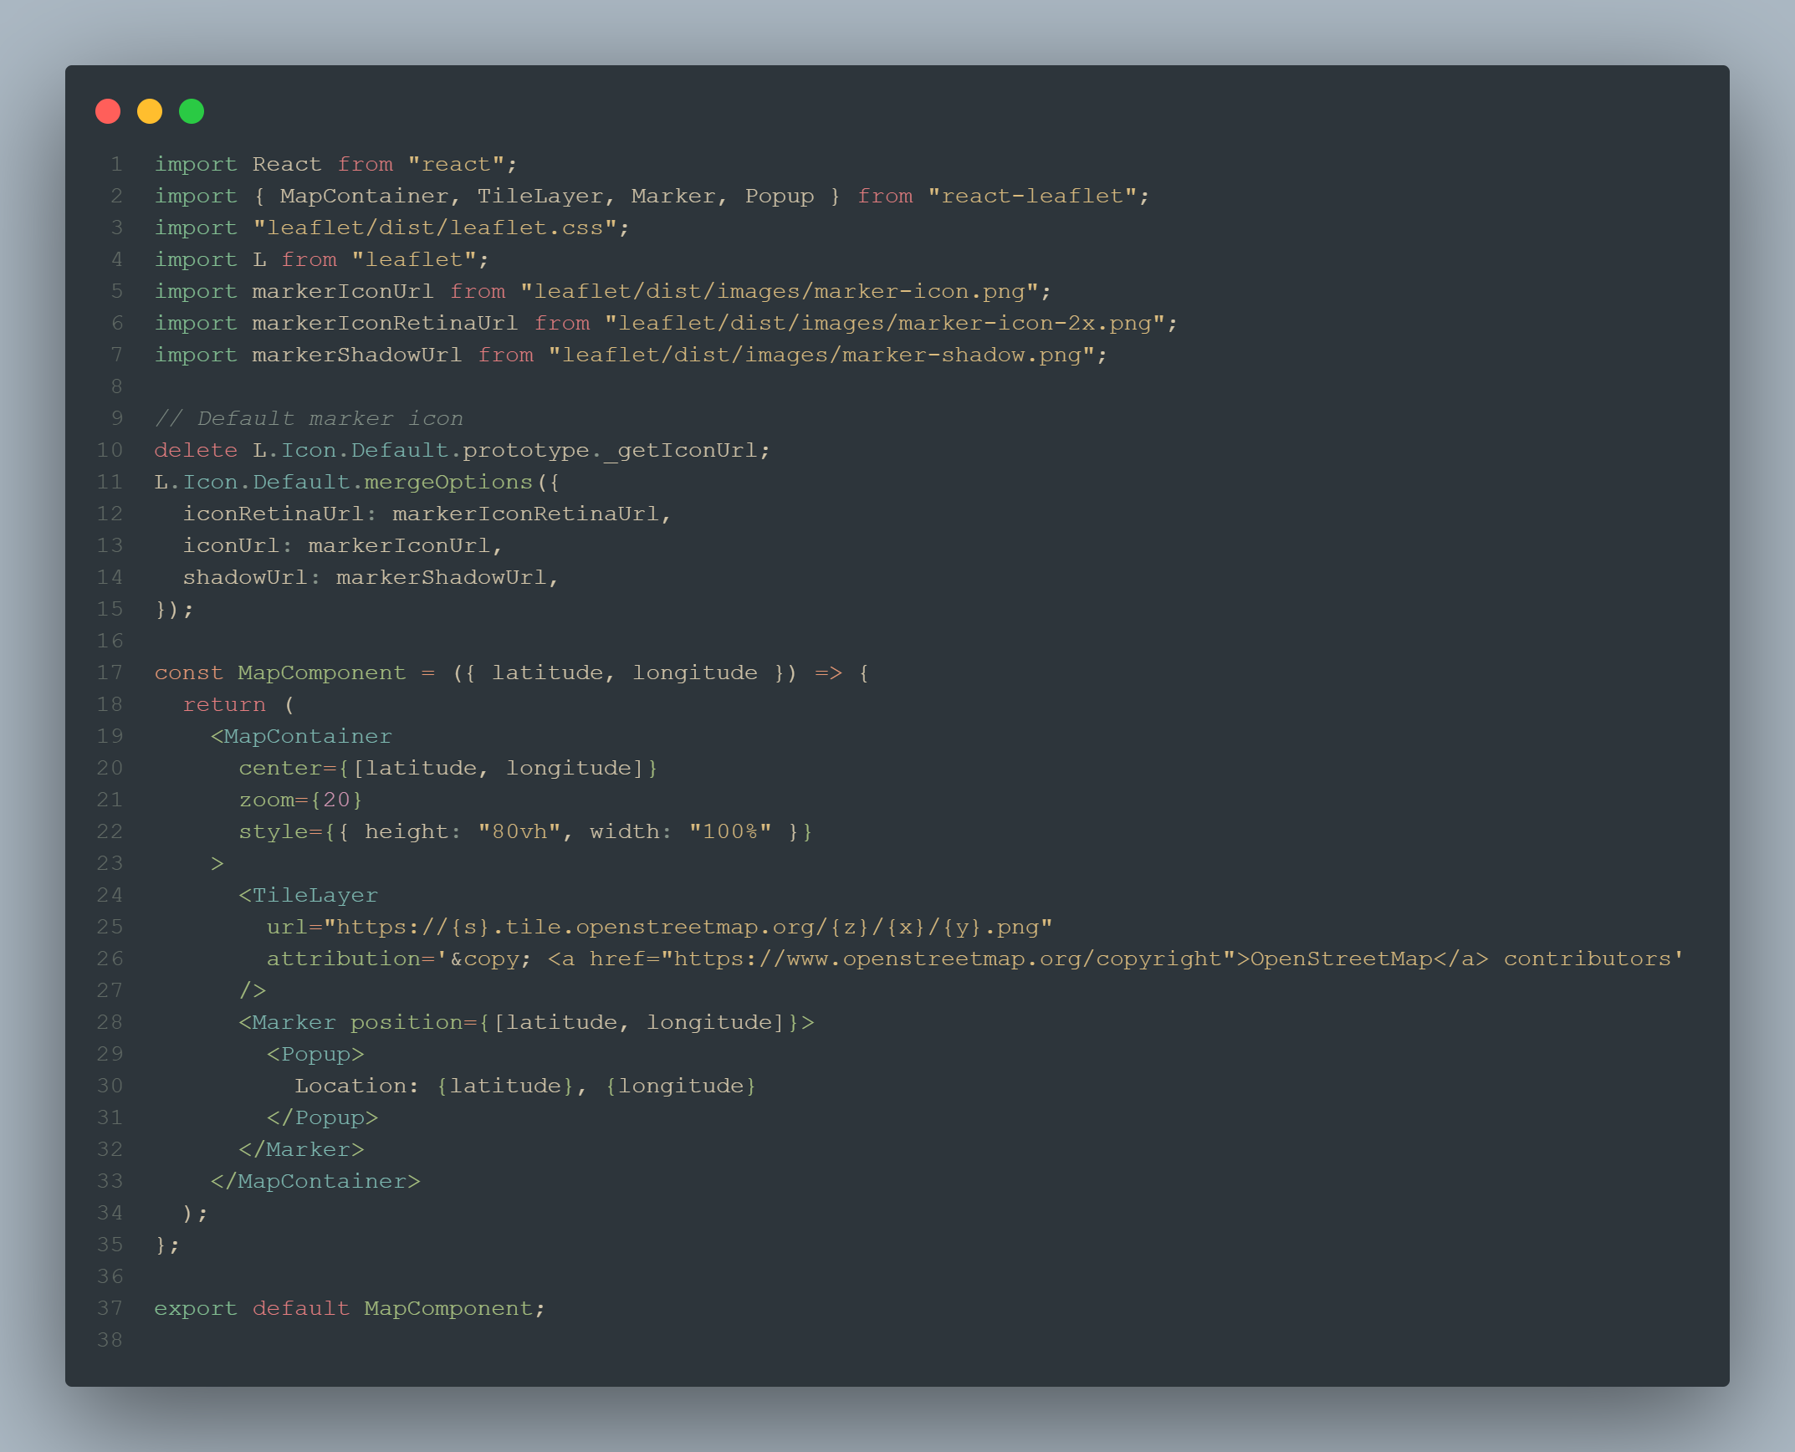

ExactLocationMap

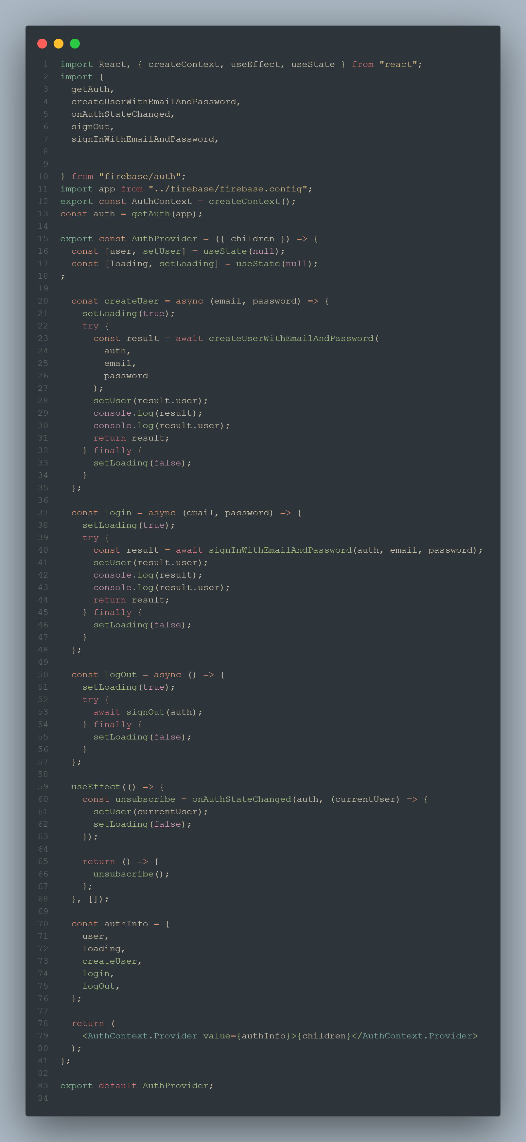

FirebasePart

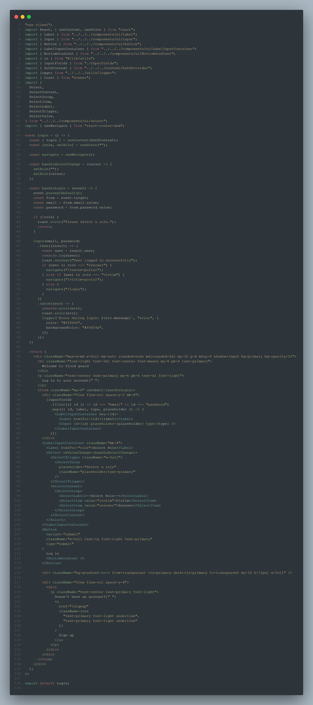

Login

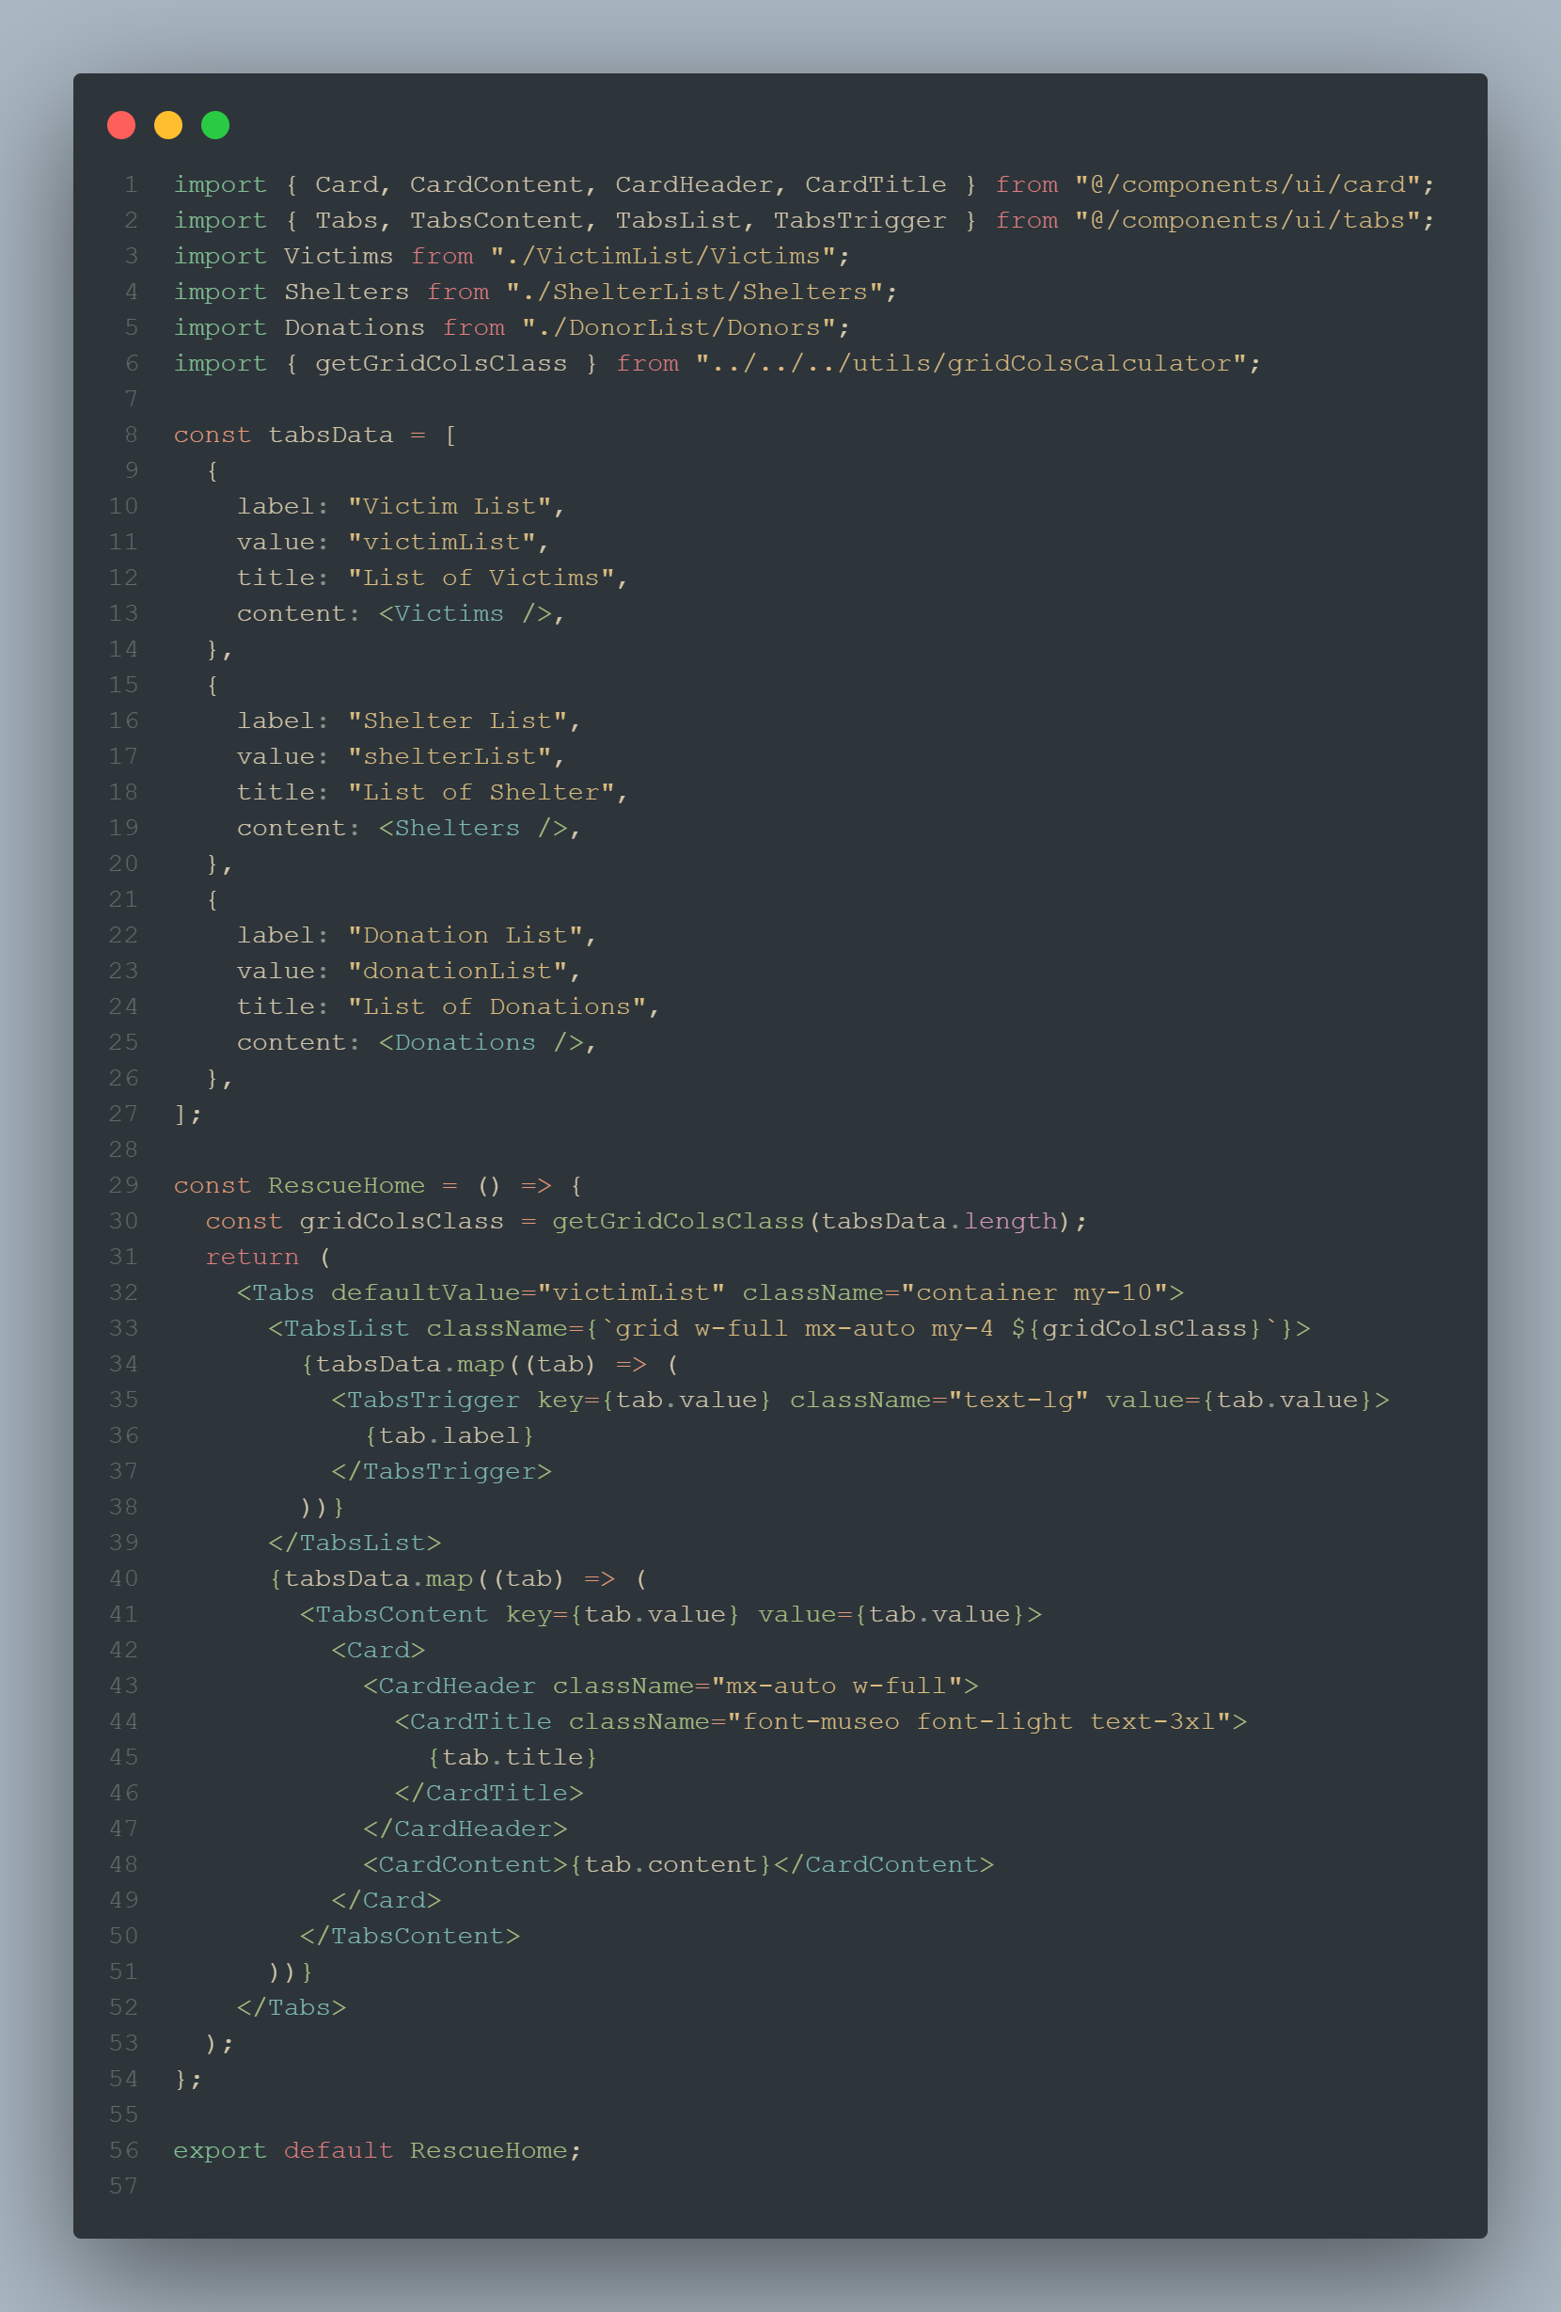

RescueHome

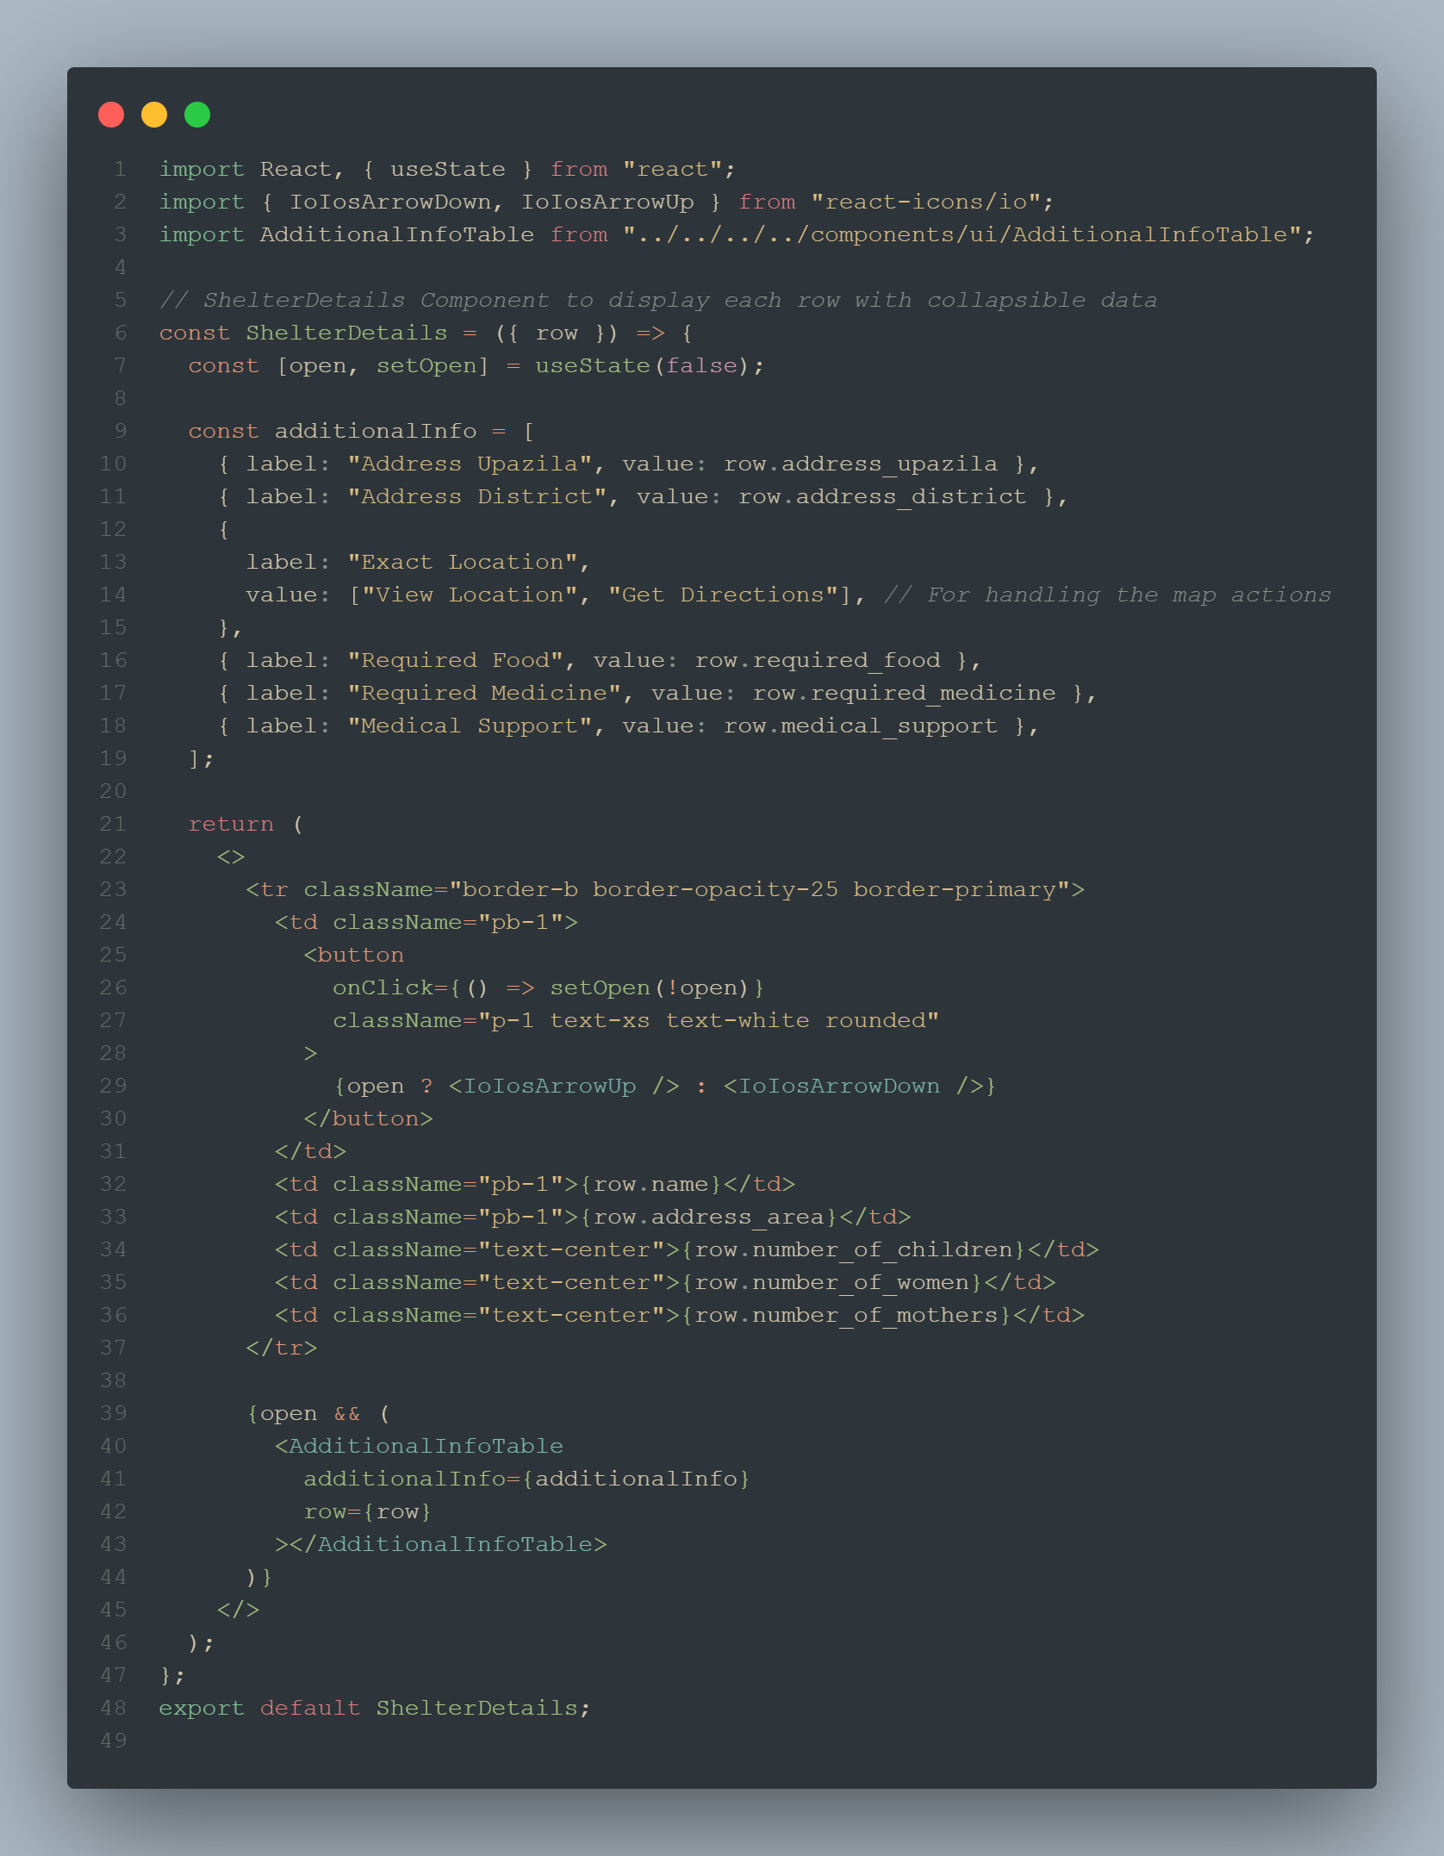

ShelterDetails

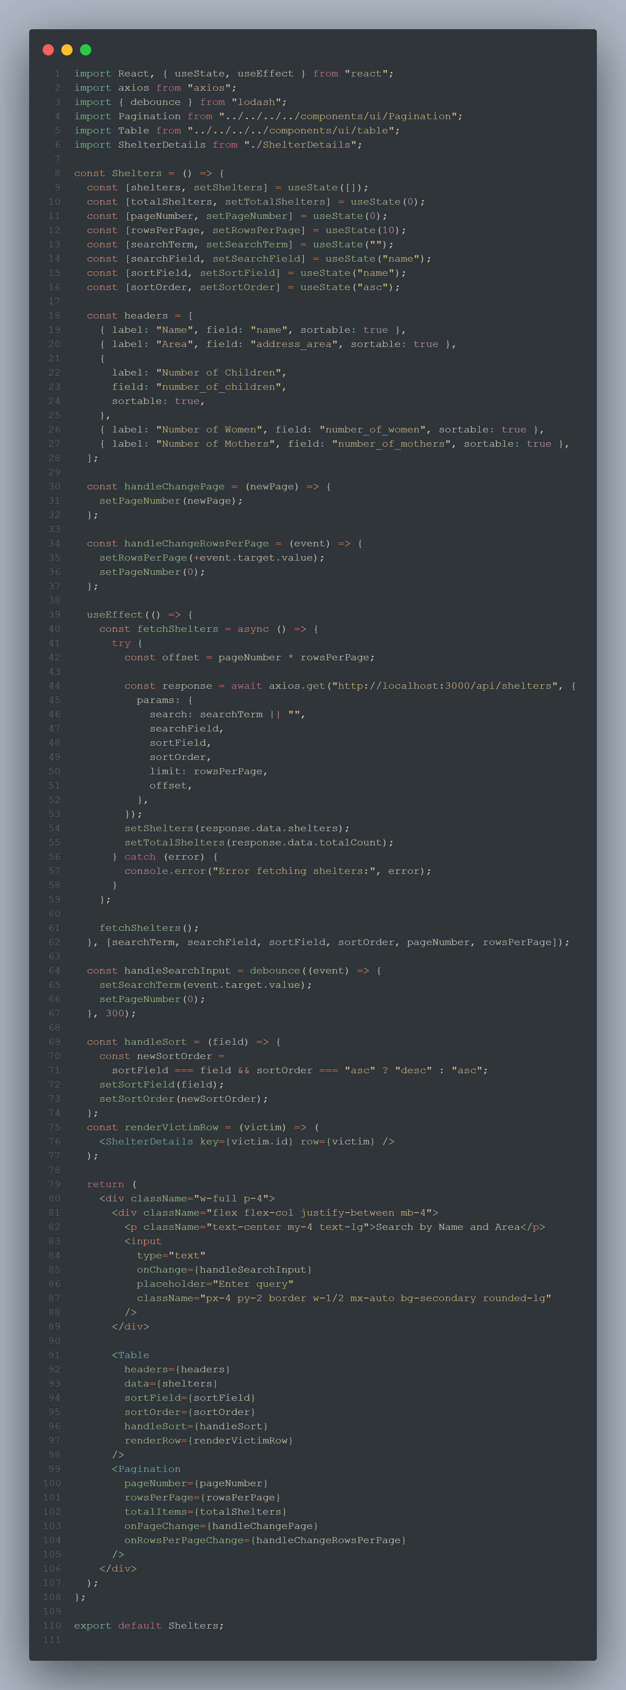

Shelters

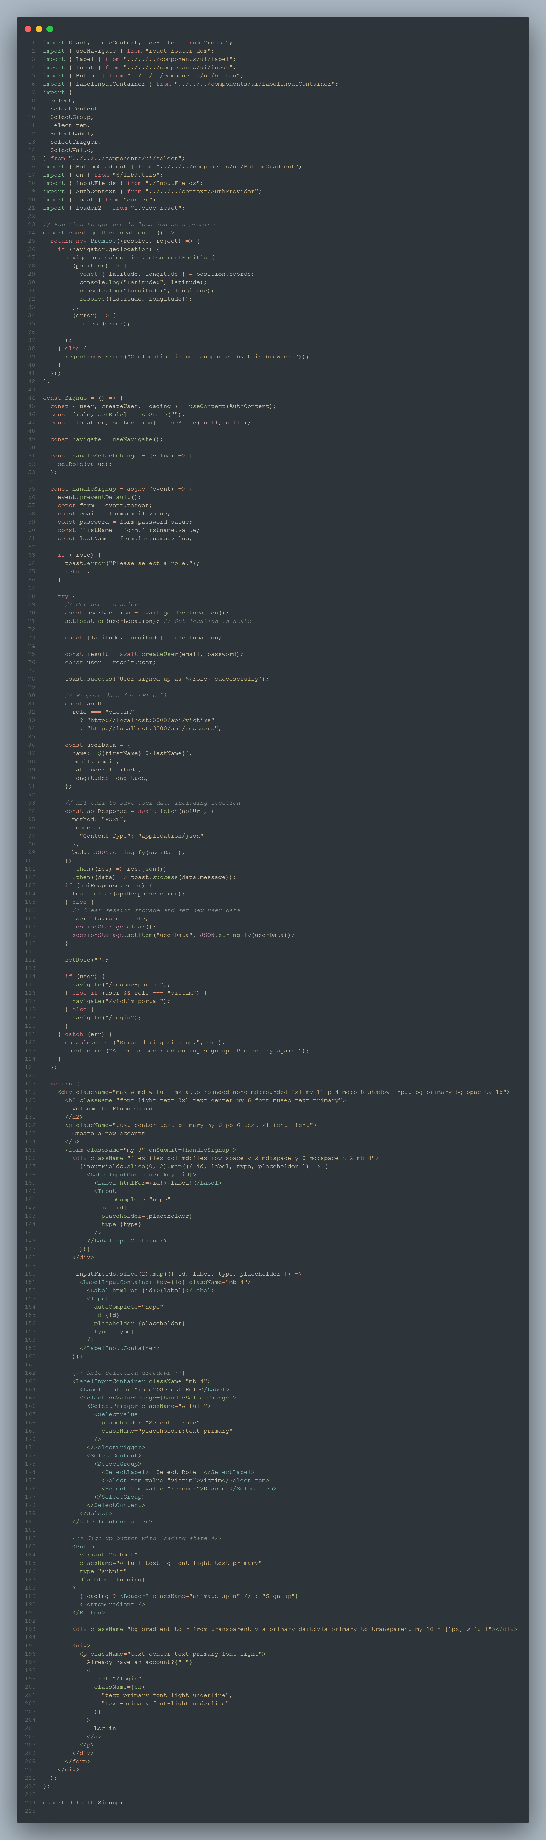

Signup

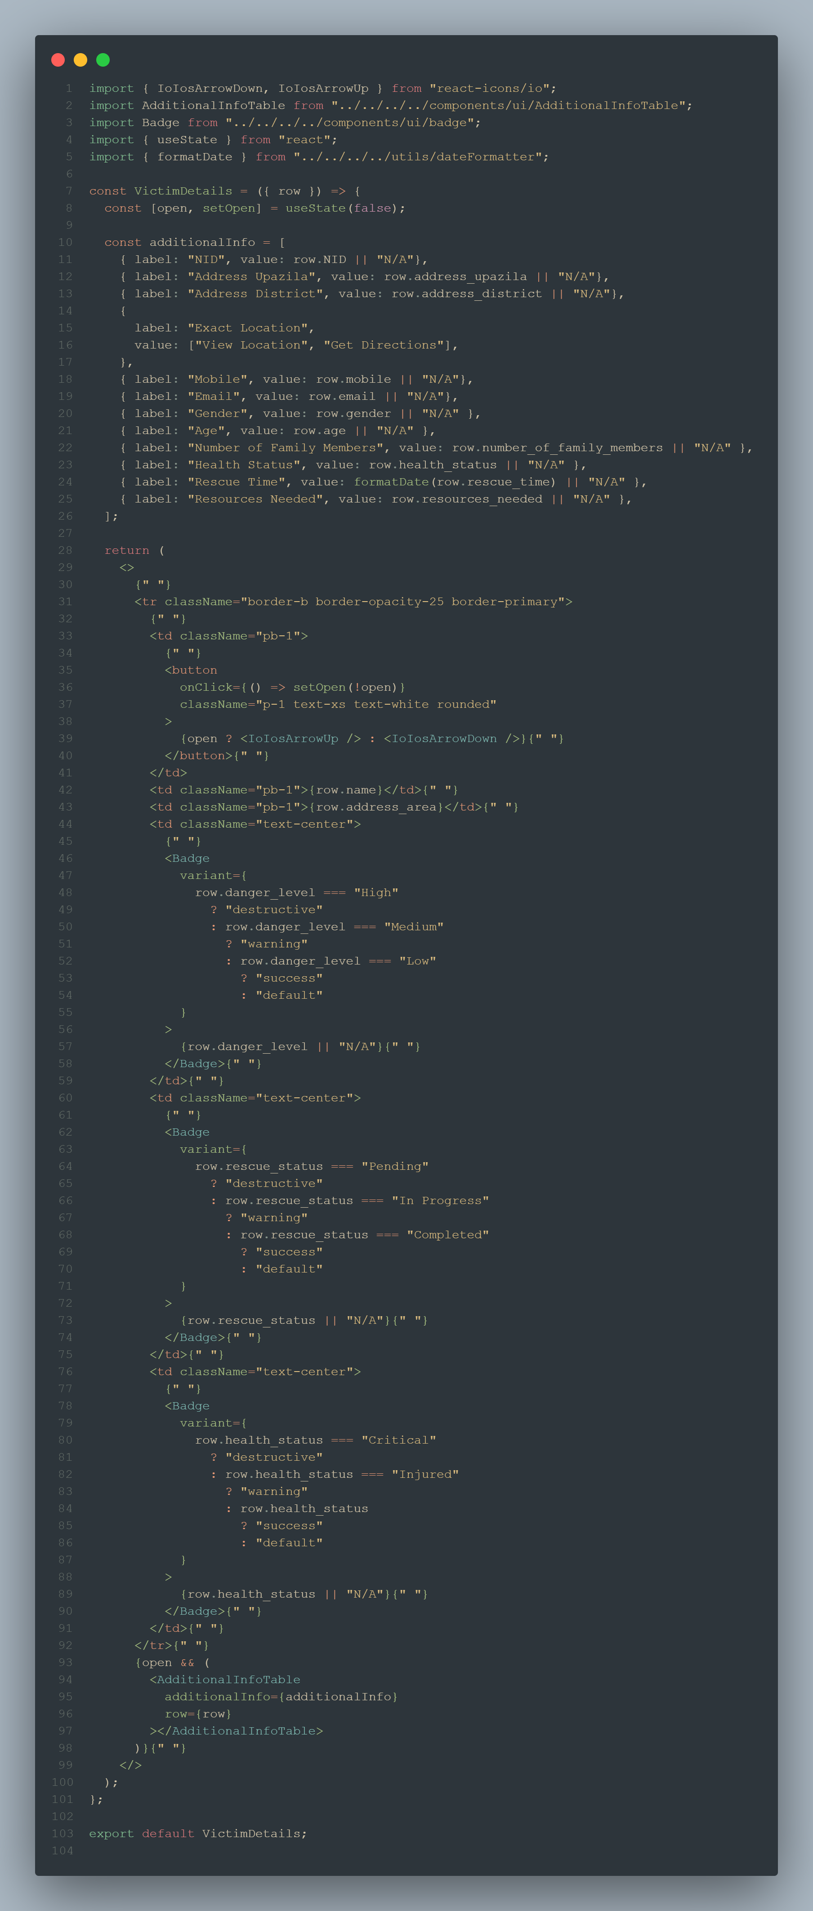

VictimDetails

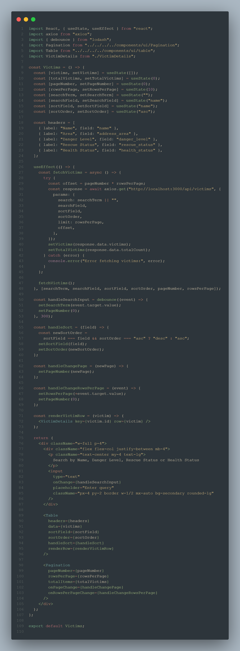

Victims